[ Insert official UPAEP logo ]
UPAEP · Decanato de Ingenierías
EVIDENCE — US17-T2
Build the irrigation history screen
SmartGreenAI: Cilantro Crop

1. Task information
Task ID | US17-T2
User Story | US-17 — Record actuator activation events
Sprint | Sprint 3 (2026-10-12 – 2026-10-30)
Week | Week 2
Responsible | Carlos Ramirez Mendoza
Peer reviewer | Jorge Velez Delgado
Planned / actual hours | 1 h / 1 h
Completed on | October 23, 2026
Status | Done

2. Task description
List events with filters by actuator and date and show total irrigation minutes per day.

3. Completion conditions
✓ Condition 1: Events listed newest first.
How it was verified: Events are listed newest first (checked on the API response: true; first row on the screen: 28 sep 2026, 10:54 p.m.).
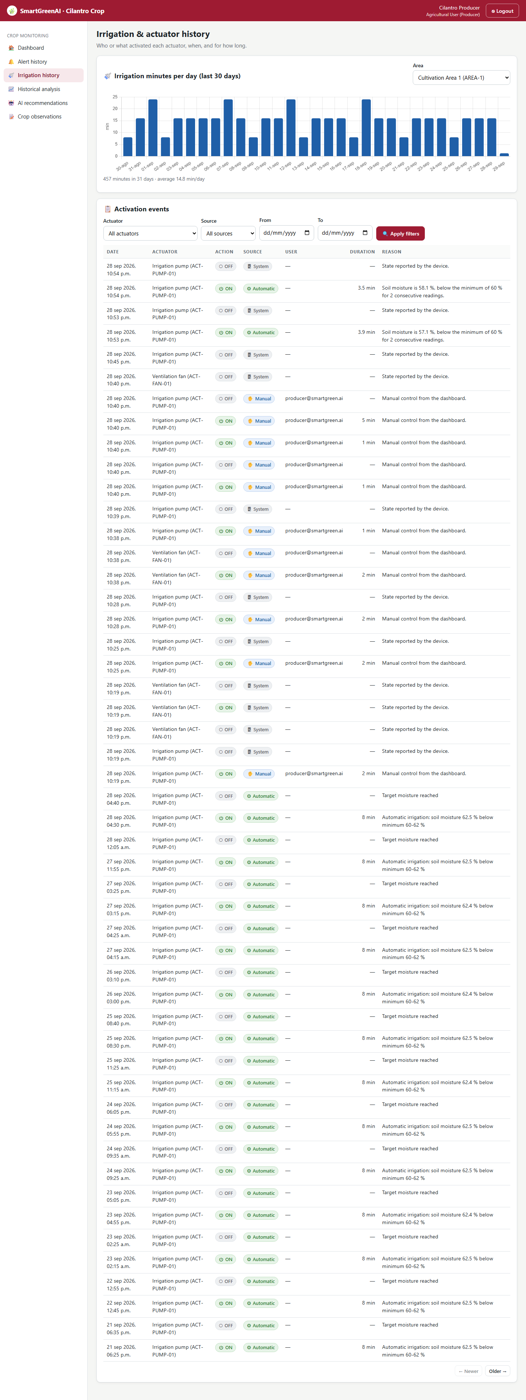
Figure US17-T2-1. Irrigation history: minutes of irrigation per day (last 30 days) and activation events, newest first. (US17-T2_Build_Irrigation_History_Screen_1.png)
Events endpoint (attached: US17-T2_Build_Irrigation_History_Screen_3.txt)
GET /api/actuators/events?actuator_id=ACT-PUMP-01&limit=10
Authorization: Bearer eyJhbG…
→ HTTP 200 OK (16 ms)
[
{
"id": "evt-05f4e3cc0b95",
"actuator_id": "ACT-PUMP-01",
"command_id": null,
"action": "OFF",
"source": "SYSTEM",
"user_id": null,
"reason": "State reported by the device.",
"duration_min": null,
"created_at": "2026-09-29T04:54:37.946Z",
"actuator_name": "Irrigation pump",
"actuator_type": "irrigation_pump",
"area_id": "AREA-1",
"user_email": null
},
… (136 more lines in the attached file)

✓ Condition 2: Filters work.
How it was verified: The filters by actuator, source and date update the table.
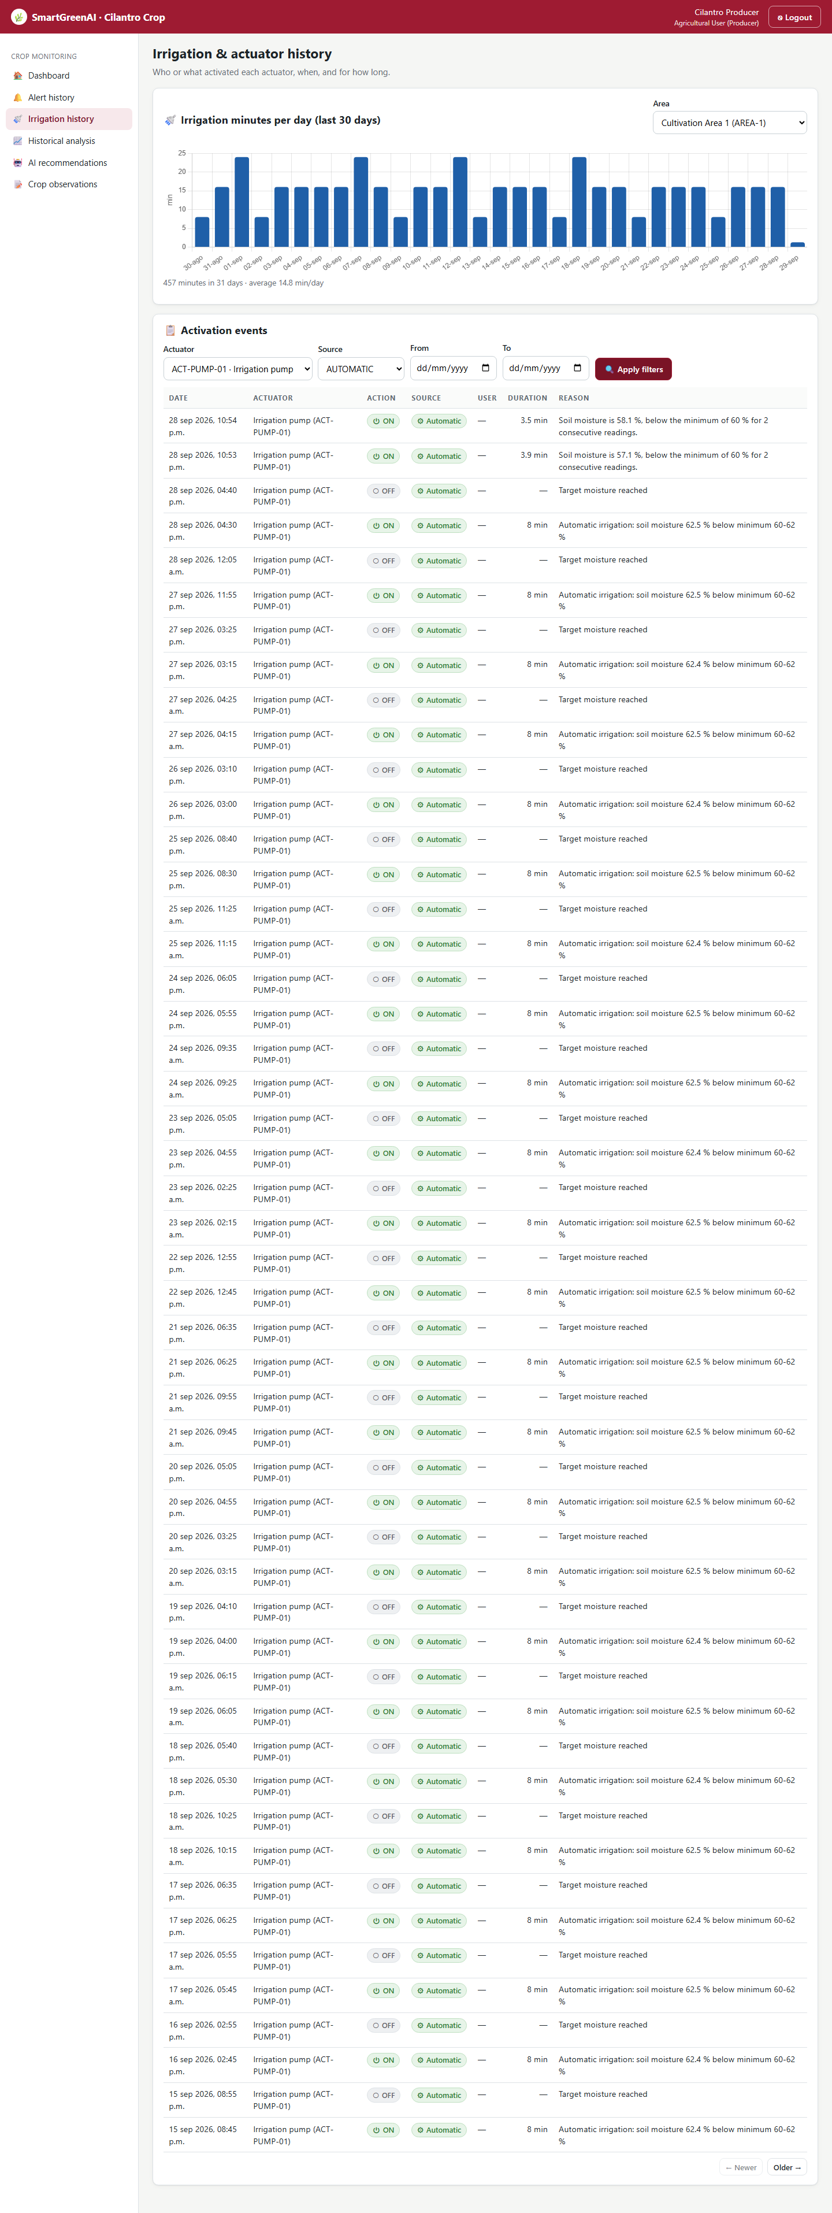
Figure US17-T2-2. Filtered by actuator ACT-PUMP-01 and source Automatic. (US17-T2_Build_Irrigation_History_Screen_2.png)
✓ Condition 3: Daily irrigation minutes shown.
How it was verified: Total irrigation minutes per day are shown as a bar chart (GET /irrigation/daily-minutes).
Daily minutes (attached: US17-T2_Build_Irrigation_History_Screen_4.txt)
GET /api/irrigation/daily-minutes?area_id=AREA-1&days=7
Authorization: Bearer eyJhbG…
→ HTTP 200 OK (15 ms)
[
{
"area_id": "AREA-1",
"day": "2026-09-29T00:00:00.000Z",
"minutes": 1.27
},
{
"area_id": "AREA-1",
"day": "2026-09-28T00:00:00.000Z",
"minutes": 16
},
{
… (30 more lines in the attached file)

✓ Condition 4: Evidence: Screenshot of the irrigation history.
How it was verified: Screenshot of the irrigation history.

4. Attached files
- US17-T2_Build_Irrigation_History_Screen_1.png
- US17-T2_Build_Irrigation_History_Screen_2.png
- US17-T2_Build_Irrigation_History_Screen_3.txt
- US17-T2_Build_Irrigation_History_Screen_4.txt

5. Traceability
Related requirements | FR-19, FR-23
Implementation | public/producer/irrigation.html, public/js/pages/irrigation-history.js (events + minutes/day chart)
Verification | screenshot

6. Sign-off
Role | Name | Date | Signature
Responsible | Carlos Ramirez Mendoza | October 23, 2026
Peer reviewer | Jorge Velez Delgado | October 23, 2026
Product Owner acceptance | Alexis Enrique Valle Parra | October 23, 2026
Approval record: Daily Meeting 3 of Sprint 3 (Monday, October 26, 2026), team update, Carlos Ramirez Mendoza (by chat): "Finished US17-T2, irrigation history screen." Daily Meeting 3 of Sprint 3 (Monday, October 26, 2026), Scrum board: "Tasks moved to Done last week: US11-T3, US11-T4, US11-T5, US12-T2, US13-T3, US15-T6, US15-T7, US16-T3, US16-T4, US17-T2, US19-T4, US19-T5, US19-T6."

